VISVESVARAYA TECHNOLOGICAL UNIVERSITY
“
JnanaSangama”, Belgaum -590014, Karnataka.
LAB REPORT on
Big Data Analytics
Submitted by
TANUSHREE DESHPANDE (1WA23CS013)
in partial fulfillment for the award of the degree of
BACHELOR OF ENGINEERING
in
COMPUTER SCIENCE AND ENGINEERING
B.M.S. COLLEGE OF ENGINEERING
(Autonomous Institution under VTU)
BENGALURU-560019
Jan-2026 to May-2026


B. M. S. College of Engineering,
Bull Temple Road, Bangalore 560019
(Affiliated To Visvesvaraya Technological University, Belgaum)
Department of Computer Science and Engineering
CERTIFICATE
This is to certify that the Lab work entitled “Big Data Analytics” carried out by TANUSHREE
DESHPANDE (1WA23CS013), who is a bona fide student of B. M. S. College of Engineering. It is in partial fulfillment for the award of Bachelor of Engineering in Computer Science and Engineering of the Visvesvaraya Technological University, Belgaum during the year 2026. The Lab report has been approved as it satisfies the academic requirements in respect of a Big Data Analytics - (23CS6PCBDA) work prescribed for the said degree.
Prof. Anita Harish
Assistant Professor
Department of CSE
BMSCE, Bengaluru
Dr. Kavitha Sooda
Professor and Head
Department of CSE
BMSCE, Bengaluru


INDEX SHEET
Sl. No.
Experiment Title
MongoDB CRUD Operations
Cassandra Employee
Page No.
1-5
1
2
3
4
5
6
7
8
9
.
.
.
.
.
.
.
.
.
6-7
Cassandra Library
Hadoop Commands
Hadoop Word Count
Hadoop Weather program
Hadoop Top N Program
Scala Program
8-9
10-11
12-14
15-20
21-24
25
Spark program
26
1
0.
Open Ended question
27-28
Course Outcome
Apply the concepts of NoSQL, Hadoop, Spark for a given task
Analyze data analytic techniques for a given problem
CO1
CO2
Conduct experiments using data analytics mechanisms for a given
problem
CO3
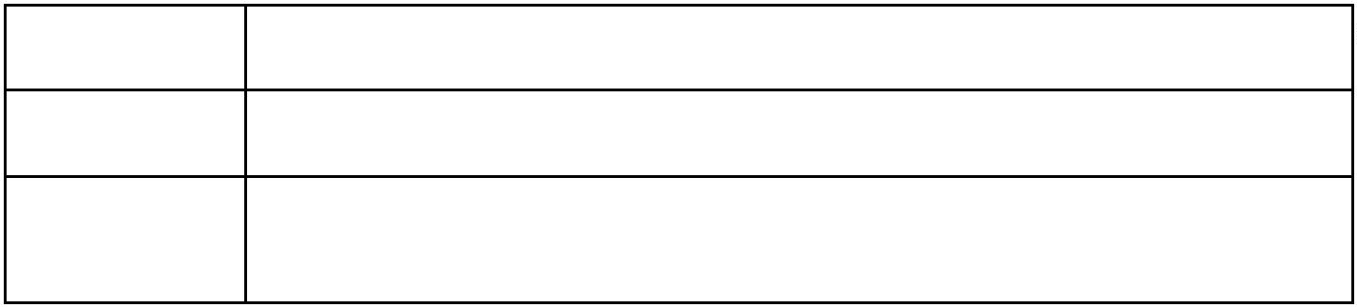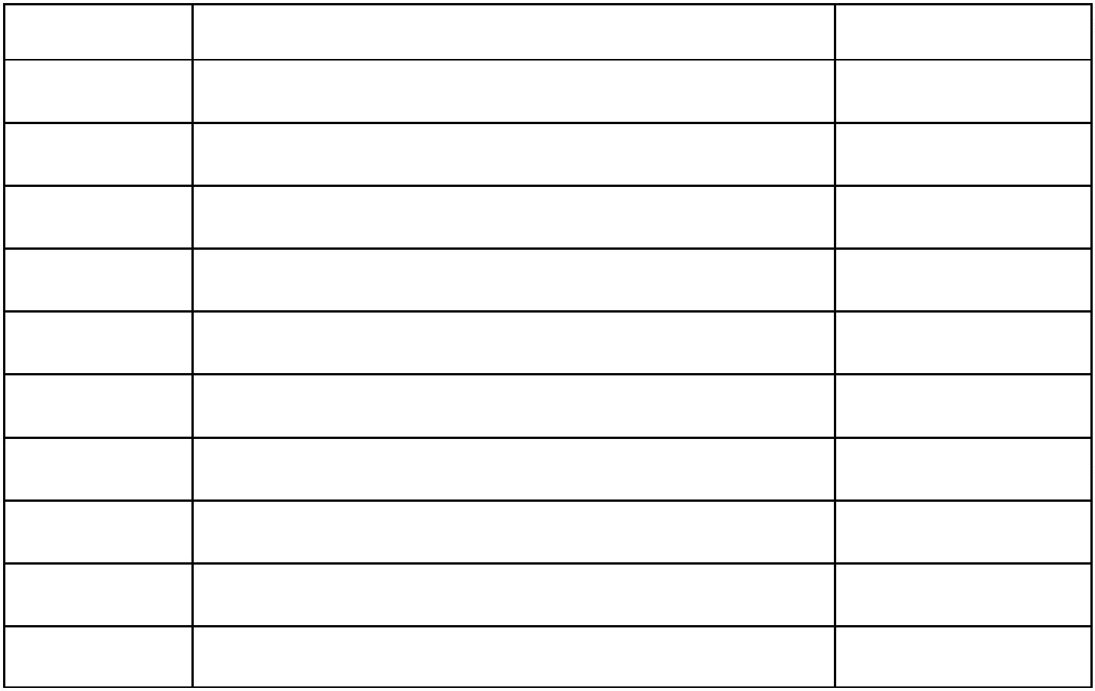
Jl;
GITHUB LINK: https://github.com/tanu808/BDA-LAB

sfvdf

LAB 1
MongoDB- CRUD Demonstration
Student database
1
2
. Create a database “Student” with the following attributes Rollno, Age, ContactNo, Email-Id.
. Insert appropriate values (at least 5)
1
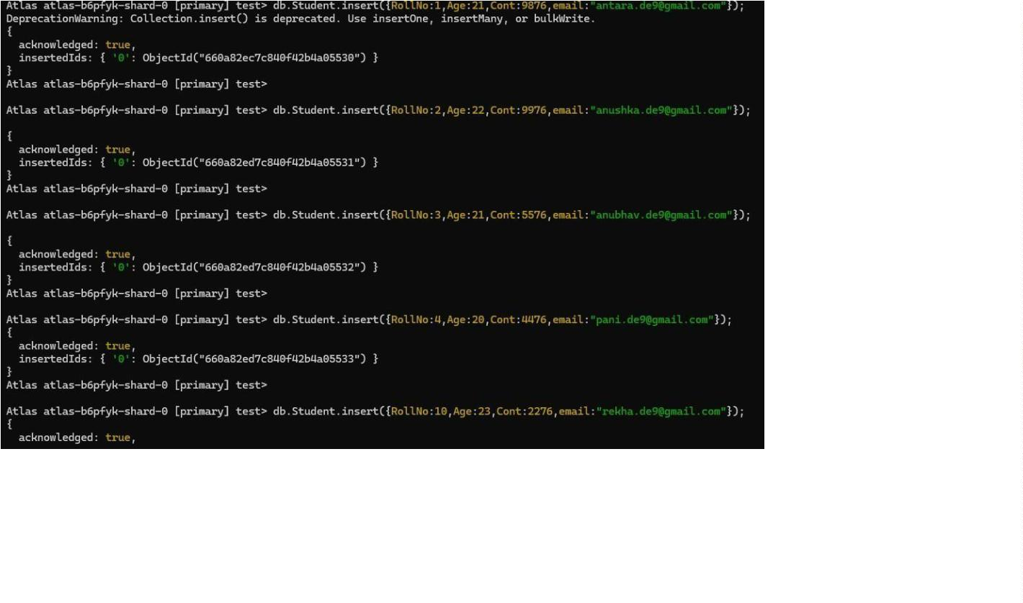

3
. View the data
4
. Write a query to update the Email-Id of a student with rollno 10.
2
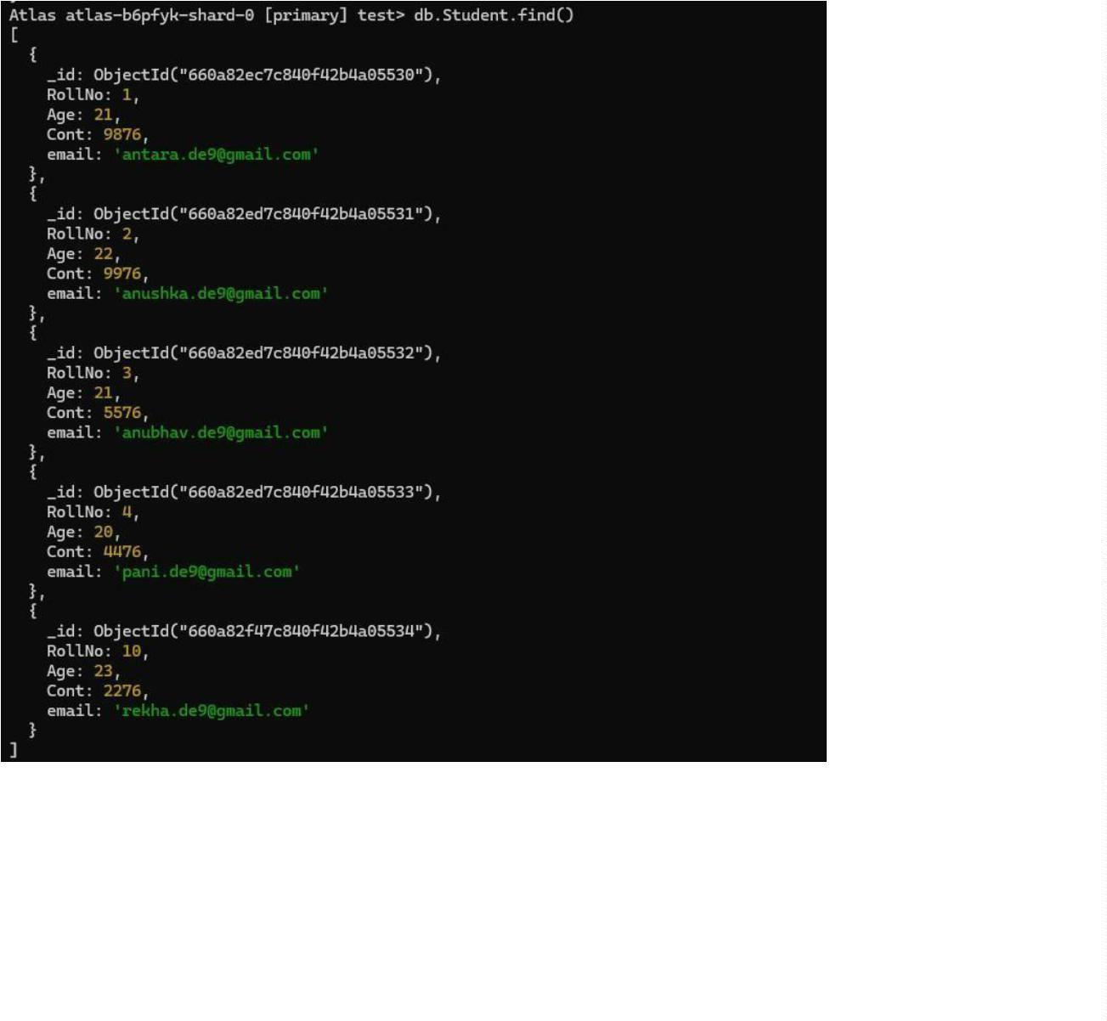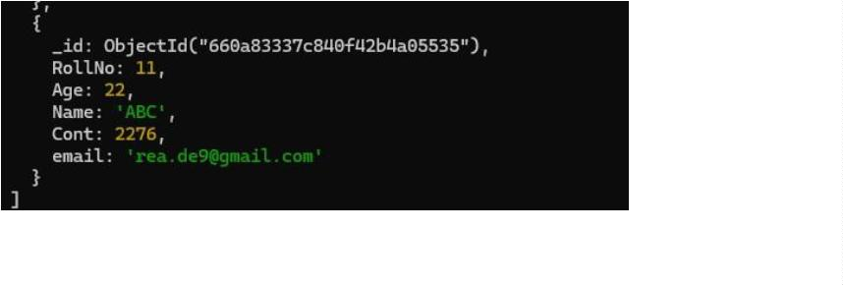

5
. Replace the student name from “ABC” to “FEM” of rollno 11.
6
7
8
. Export the created table into local file system
. Drop the table
. Import a given csv dataset from local file system into mongodb collection.
Customer database
1
. Create a collection by name Customers with the following attributes. Cust_id, Acc_Bal,
Acc_Type
3
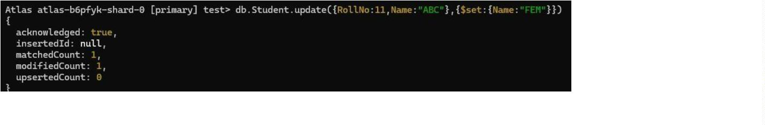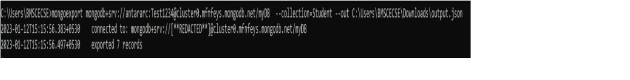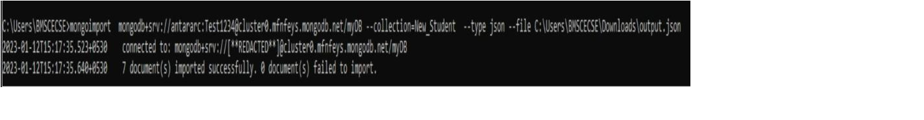

2
. Insert at least 5 values into the table
3
. Write a query to display those records whose total account balance is greater than 1200 of
account type ‘Z’ for each customer_id.
4
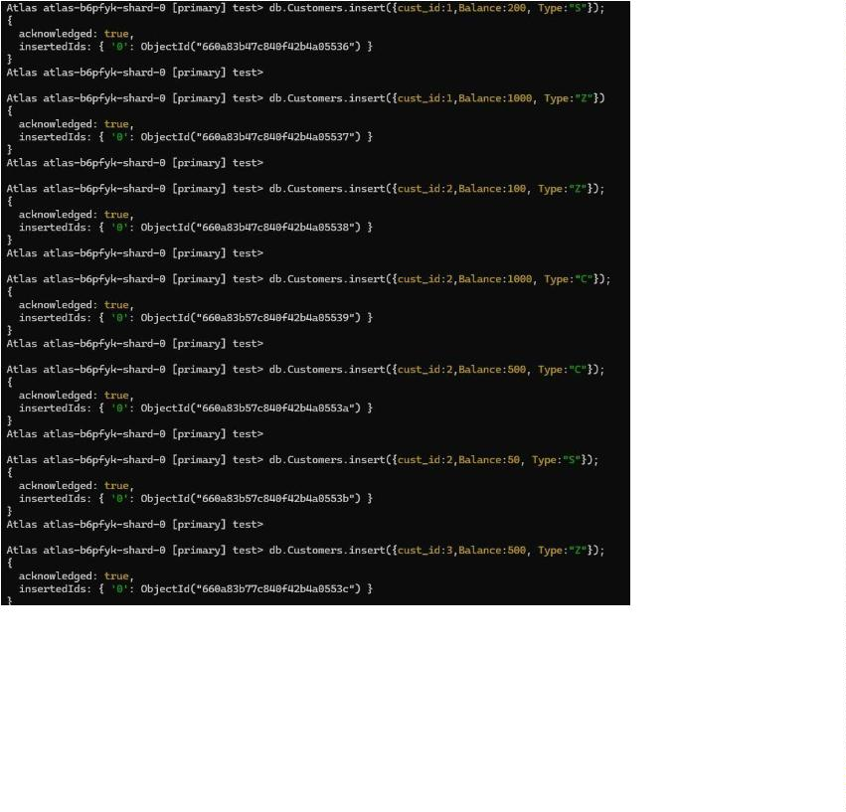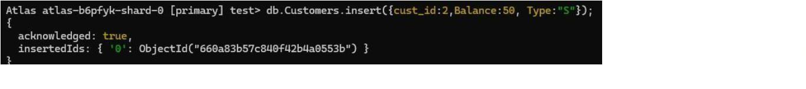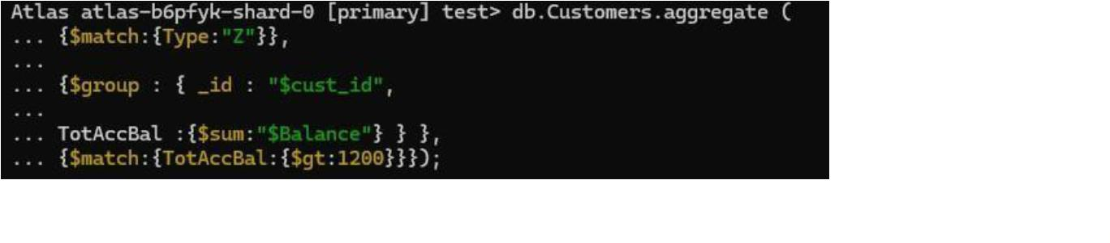

4
. Determine Minimum and Maximum account balance for each customer_id.
5
. Drop the table
5
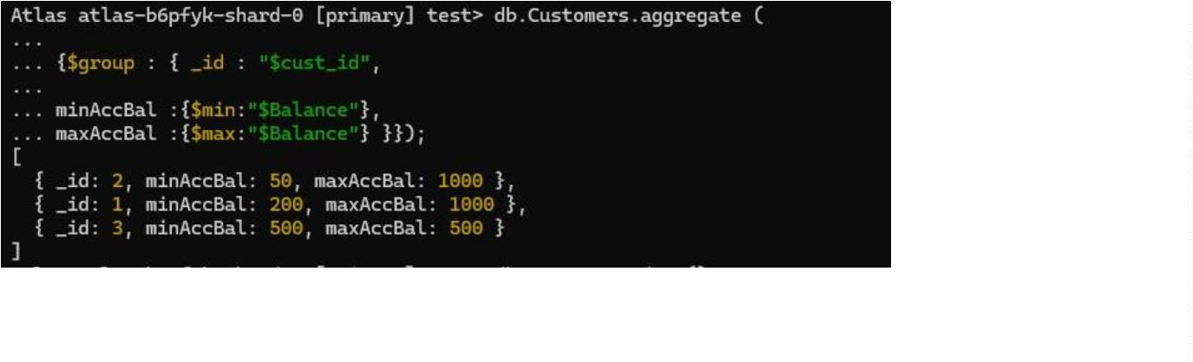

LAB
2
Perform the following DB operations using Cassandra
Employee Database
1
2
.
.
Create a keyspace by name Employee
Create a column family by name Employee-Info with attributes Emp_Id Primary Key,
Emp_Name, Designation, Date_of_Joining, Salary, Dept_Name
Insert the values into the table in batch
3
.
4
5
.
.
Update Employee name and Department of Emp-Id 121
Sort the details of Employee records based on salary
6
7
.
.
Alter the schema of the table Employee_Info to add a column Projects which stores a set
of Projects done by the corresponding Employee.
Update the altered table to add project names.
6
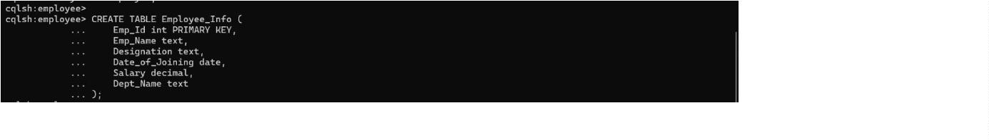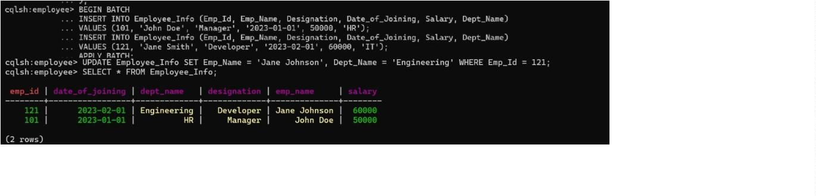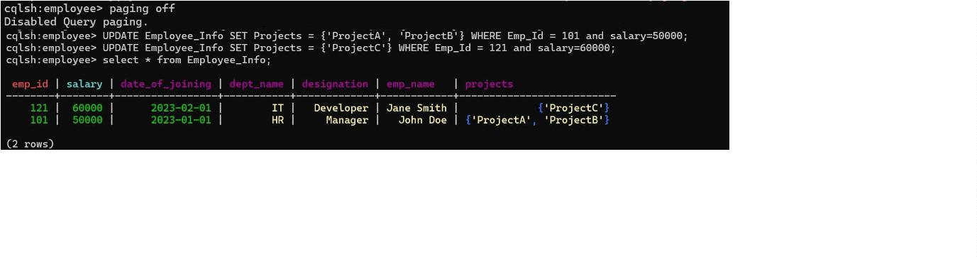

8
.
Create a TTL of 15 seconds to display the values of Employees.
7
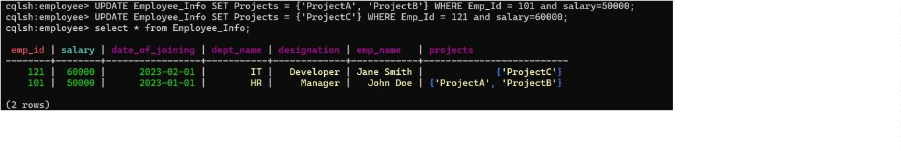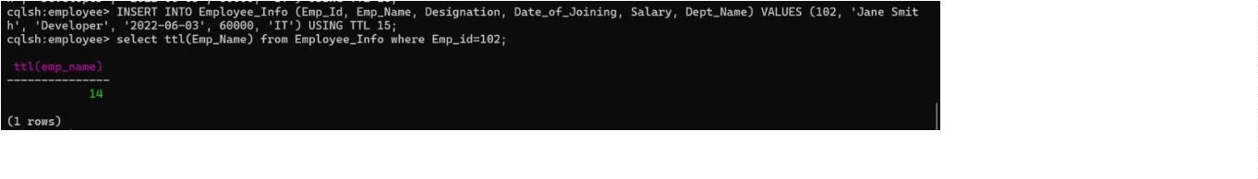

LAB
3
Perform the following DB operations using Cassandra
1
. Create a keyspace by name Library
2
. Create a column family by name Library-Info with attributes
Stud_Id Primary Key, Counter_value of type Counter,
Stud_Name, Book-Name, Book-Id, Date_of_issue
3
4
. Insert the values into the table in batch
. Display the details of the table created and increase the value of the counter
5
. Write a query to show that a student with id 112 has taken a book “BDA” 2 times.
8
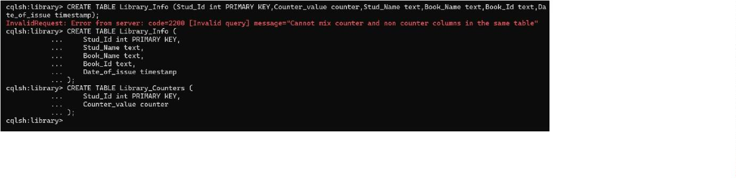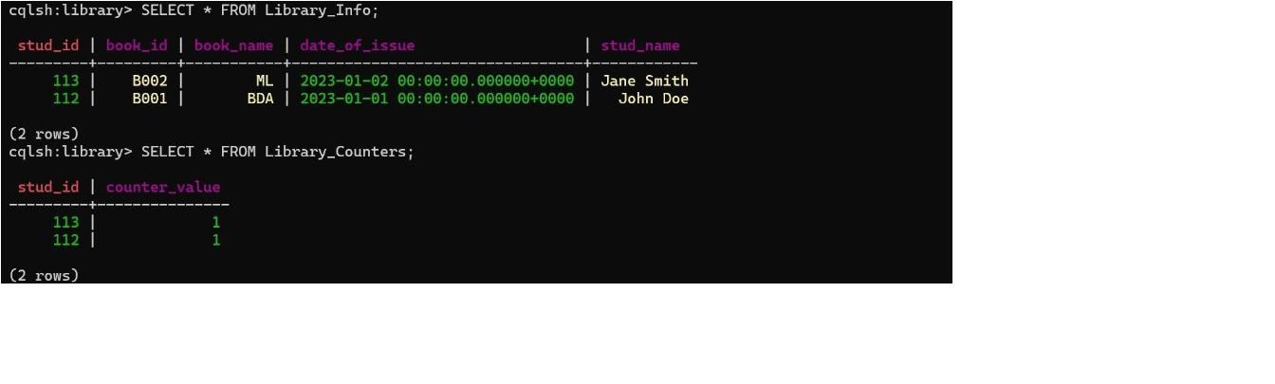

6
7
. Export the created column to a csv file
. Import a given csv dataset from local file system into Cassandra column family
9
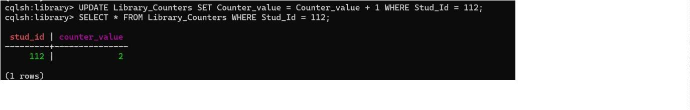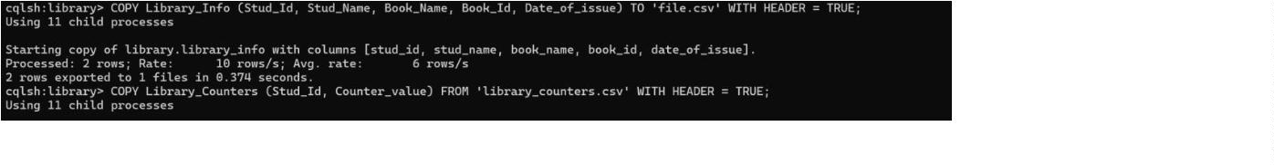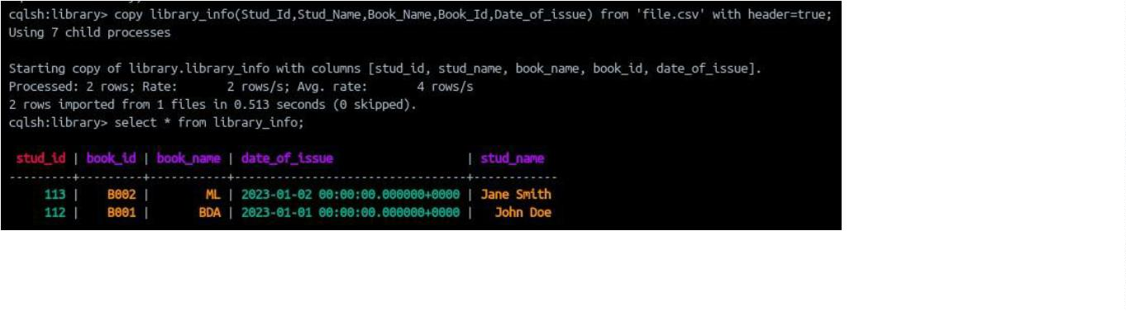

LAB
4
Execution of HDFS Commands for interaction with Hadoop Environment.
(Minimum 10 commands to be executed)
1
2
. mkdir
. ls
3
. put
4
5
. copyFromLocal
. get
10
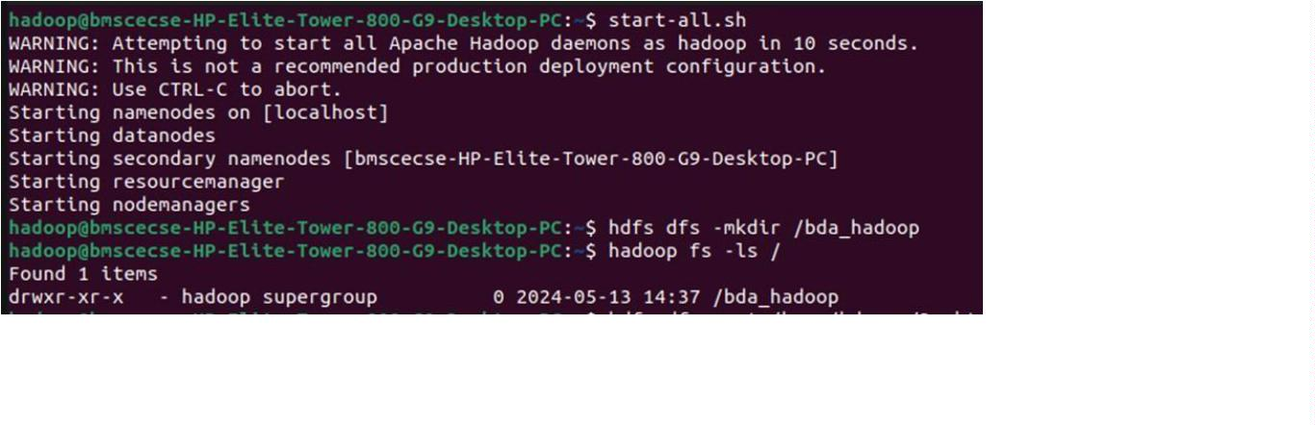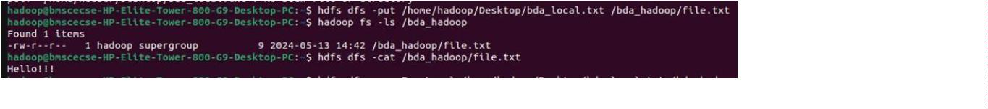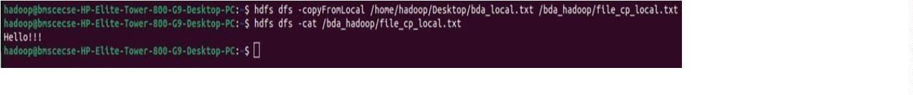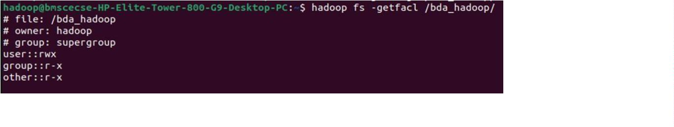

6
. copyToLocal
7
8
. cat
. mv
9
. cp
11
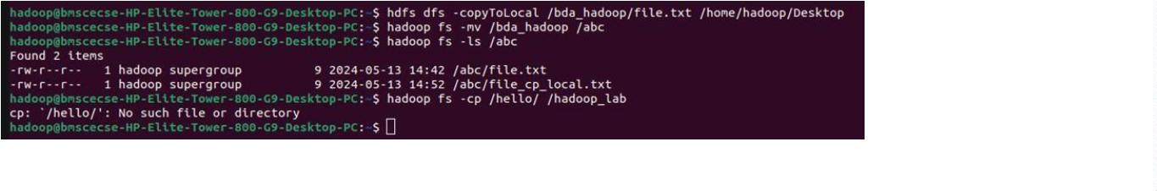

LAB
5
Implement WordCount Program on Hadoop framework
Word Count Program:
Mapper code: You have to copy paste this program into the WCMapper Java Class file
import
java.io.IOException;
import
org.apache.hadoop.io.IntWritable;
import
import
import
import
import
org.apache.hadoop.io.LongWritable;
org.apache.hadoop.mapred.MapReduceBase;
org.apache.hadoop.mapred.Mapper;
org.apache.hadoop.mapred.OutputCollector;
org.apache.hadoop.mapred.Reporter;
import org.apache.hadoop.io.Text;
public class WCMapper extends MapReduceBase implements Mapper<LongWritable, Text,
Text, IntWritable> { public void map(LongWritable key, Text value, OutputCollector<Text,
IntWritable> output,
Reporter rep) throws IOException { String line =
value.toString(); for (String word : line.split(" ")) { if
(word.length() > 0) { output.collect(new Text(word),
new IntWritable(1)); }
}
}
}
Reducer Code: You have to copy paste this program into the WCReducer Java Class file
import
java.io.IOException;
import
import
java.util.Iterator;
org.apache.hadoop.io.Text;
import
import
import
import
org.apache.hadoop.io.IntWritable;
org.apache.hadoop.mapred.MapReduceBase;
org.apache.hadoop.mapred.OutputCollector;
org.apache.hadoop.mapred.Reducer; import org.apache.hadoop.mapred.Reporter;
public class WCReducer extends MapReduceBase implements Reducer<Text, IntWritable, Text,
IntWritable> { public void reduce(Text key, Iterator<IntWritable> value, OutputCollector<Text,
IntWritable>
output, Reporter rep) throws IOException { int
count = 0;
while
(value.hasNext())
{
IntWritable i = value.next();
count += i.get();
}
output.collect(key, new
IntWritable(count)); }
}
Driver Code: You have to copy paste this program into the WCDriver Java Class file.
import java.io.IOException; import org.apache.hadoop.conf.Configured; import
org.apache.hadoop.fs.Path;
org.apache.hadoop.io.Text;
import
import
org.apache.hadoop.io.IntWritable;
org.apache.hadoop.mapred.FileInputFormat;
import
12

import
org.apache.hadoop.mapred.FileOutputFormat;
import
org.apache.hadoop.mapred.JobClient; import org.apache.hadoop.mapred.JobConf;
import org.apache.hadoop.util.Tool; import org.apache.hadoop.util.ToolRunner;
public class WCDriver extends Configured implements Tool { public int run(String[]
args) throws IOException { if (args.length < 2) {
System.out.println("Please give valid inputs"); return
-1;
}
JobConf conf = new JobConf(WCDriver.class); conf.setJobName("Word
Count");
FileInputFormat.setInputPaths(conf, new Path(args[0]));
FileOutputFormat.setOutputPath(conf,
new
Path(args[1])); conf.setMapperClass(WCMapper.class);
conf.setReducerClass(WCReducer.class);
conf.setMapOutputKeyClass(Text.class);
conf.setMapOutputValueClass(IntWritable.class);
conf.setOutputKeyClass(Text.class);
conf.setOutputValueClass(IntWritable.class);
JobClient.runJob(conf); return 0;
}
{
public static void main(String[] args) throws Exception
int
exitCode
=
ToolRunner.run(new
WCDriver(),
args);
System.out.println(exitCode);
}
}
13

OUTPUT
14
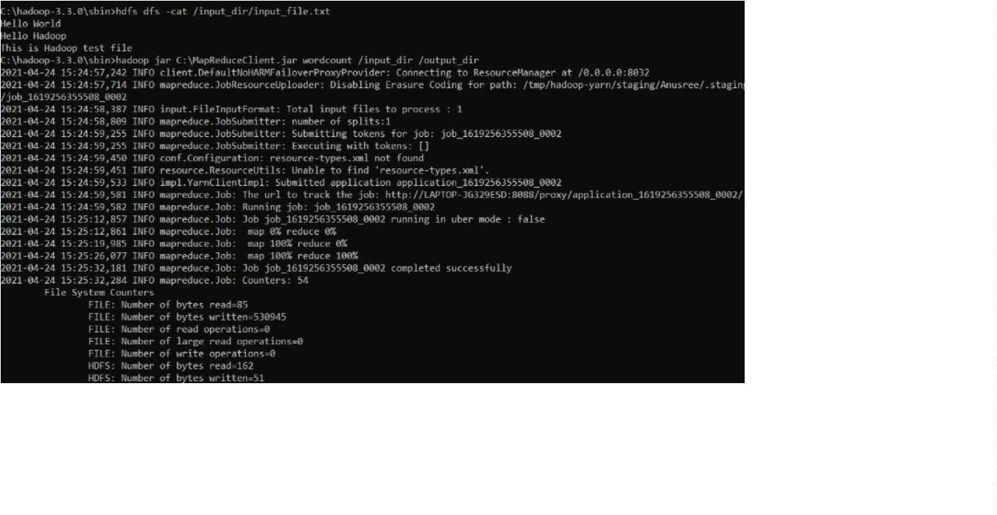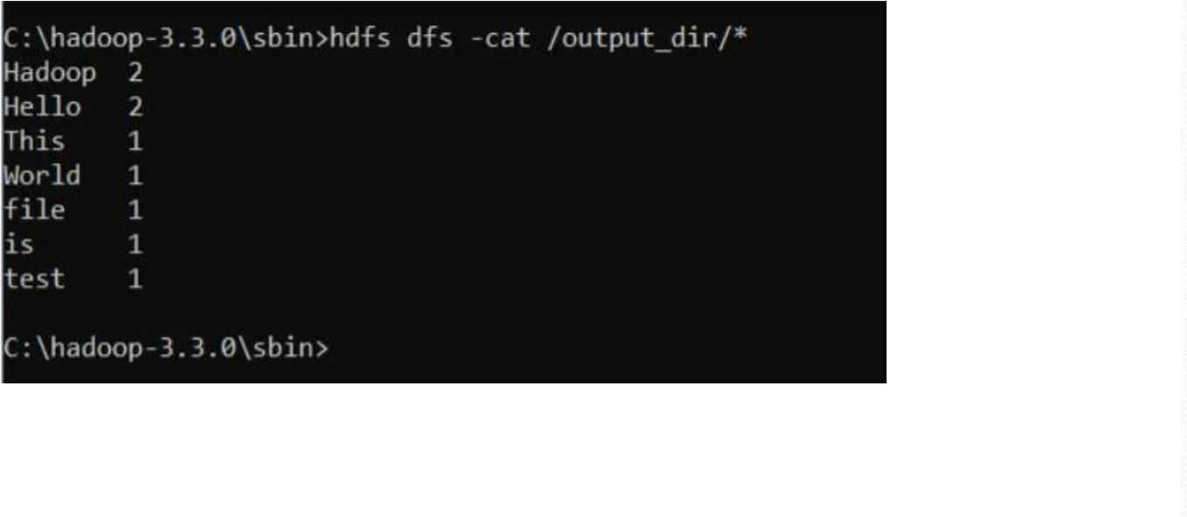

LAB 6
From the following link extract the weather data
https://github.com/tomwhite/hadoop-Book/tree/master/input/ncdc/all
Create a Map Reduce program to
a) find average temperature for each year from the NCDC data set.
AverageDriver package temp; import org.apache.hadoop.fs.Path;
import
org.apache.hadoop.io.IntWritable;
import
import
import
import
org.apache.hadoop.io.Text;
org.apache.hadoop.mapreduce.Job;
org.apache.hadoop.mapreduce.lib.input.FileInputFormat;
org.apache.hadoop.mapreduce.lib.output.FileOutputFormat; public
class AverageDriver { public static void main(String[] args) throws
Exception { if (args.length != 2) {
System.err.println("Please Enter the input and output parameters"); System.exit(-1);
}
Job job = Job.getInstance();
job.setJarByClass(AverageDriver.class);
job.setJobName("Max temperature");
FileInputFormat.addInputPath(job, new Path(args[0]));
FileOutputFormat.setOutputPath(job,
Path(args[1]));
new
job.setMapperClass(AverageMapper.class);
job.setReducerClass(AverageReducer.class);
job.setOutputKeyClass(Text.class);
job.setOutputValueClass(IntWritable.class);
System.exit(job.waitForCompletion(true) ? 0 : 1); }
}
AverageMapper package temp; import java.io.IOException; import
org.apache.hadoop.io.IntWritable; import org.apache.hadoop.io.LongWritable; import
org.apache.hadoop.io.Text; import org.apache.hadoop.mapreduce.Mapper; public class
AverageMapper extends Mapper<LongWritable, Text, Text, IntWritable> { public
static final int MISSING = 9999; public void map(LongWritable key, Text value,
Context context) throws IOException,
InterruptedException { int
temperature;
String line = value.toString();
if (line.length() < 93) {
return;
15

}
String year = line.substring(15, 19); if (line.charAt(87)
==
'+')
{
temperature
=
Integer.parseInt(line.substring(88, 92));
}
else { temperature = Integer.parseInt(line.substring(87,
92));
}
String quality = line.substring(92, 93); if (temperature !=
MISSING && quality.matches("[01459]")) { context.write(new
Text(year), new IntWritable(temperature));
}
}
}
AverageReducer
package
temp;
import
org.apache.hadoop.mapreduce.Reducer; public
import
org.apache.hadoop.io.Text;
class AverageReducer
java.io.IOException;
import
import
extends
org.apache.hadoop.io.IntWritable;
Reducer<Text, IntWritable, Text, IntWritable> { public void reduce(Text key,
Iterable<IntWritable> values,
Context context) throws IOException, InterruptedException {
int sum = 0; int count = 0; for
(IntWritable value : values) {
sum += value.get(); count++;
}
if (count > 0) { int average = sum / count;
context.write(key, new IntWritable(average));
}
}
}
16

OUTPUT
b) find the mean max temperature for every month
MeanMaxDriver.class package
meanmax; import
org.apache.hadoop.fs.Path; import
org.apache.hadoop.io.IntWritable; import
org.apache.hadoop.io.Text; import
org.apache.hadoop.mapreduce.Job;
import
org.apache.hadoop.mapreduce.lib.input.FileInputFormat;
import org.apache.hadoop.mapreduce.lib.output.FileOutputFormat;
public class MeanMaxDriver {
17
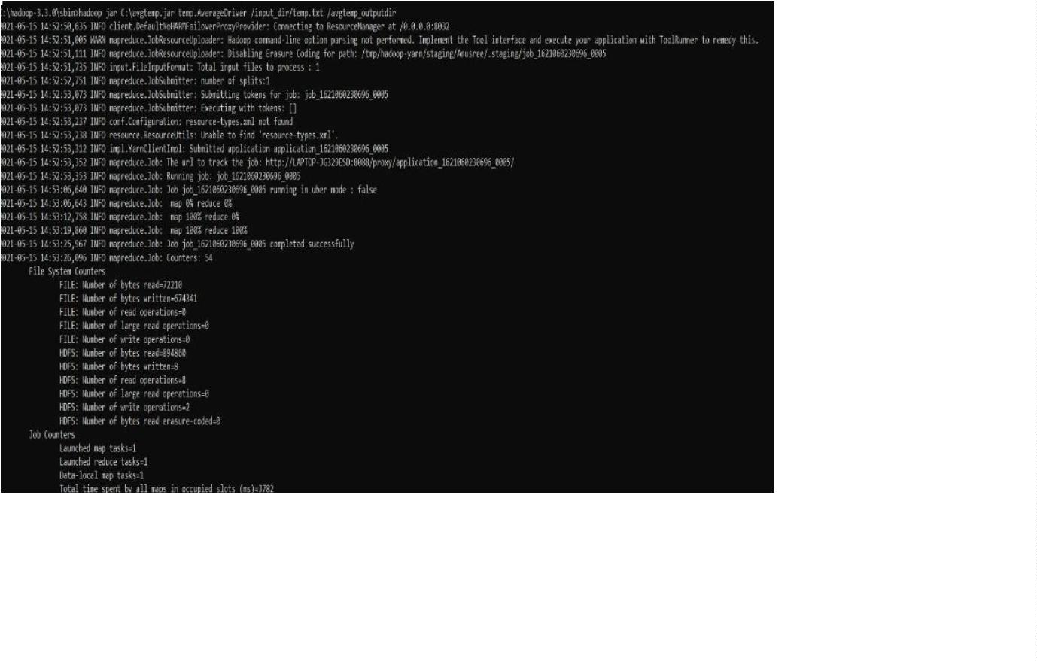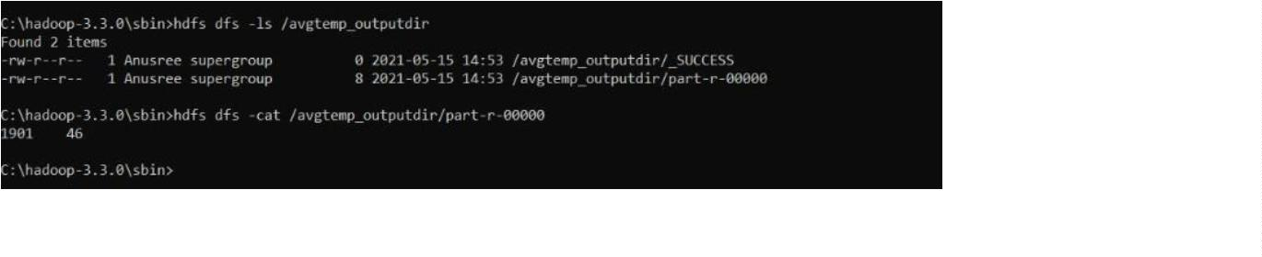

public static void main(String[] args) throws Exception {
if (args.length != 2) {
System.err.println("Please enter the input and output parameters"); System.exit(-1);
}
Job
job.setJarByClass(MeanMaxDriver.class);
job.setJobName("Mean and Max Temperature");
FileInputFormat.addInputPath(job, new Path(args[0]));
job
=
Job.getInstance();
FileOutputFormat.setOutputPath(job,
Path(args[1]));
new
job.setMapperClass(MeanMaxMapper.class);
job.setReducerClass(MeanMaxReducer.class);
job.setOutputKeyClass(Text.class);
job.setOutputValueClass(IntWritable.class);
System.exit(job.waitForCompletion(true) ? 0 : 1); }
}
MeanMaxMapper.class package meanmax; import java.io.IOException; import
org.apache.hadoop.io.IntWritable; import org.apache.hadoop.io.LongWritable; import
org.apache.hadoop.io.Text; import org.apache.hadoop.mapreduce.Mapper; public class
MeanMaxMapper extends Mapper<LongWritable, Text, Text, IntWritable> { public static
final int MISSING = 9999; public void map(LongWritable key, Text value, Context
context) throws IOException, InterruptedException {
int temperature;
String line = value.toString(); if
(line.length() < 93) return;
String month = line.substring(19, 21);
if
(line.charAt(87)
==
'+')
{
temperature = Integer.parseInt(line.substring(88, 92));
else { temperature = Integer.parseInt(line.substring(87,
}
}
9
2));
String quality = line.substring(92, 93); if (temperature !=
MISSING && quality.matches("[01459]")) { context.write(new
Text(month), new IntWritable(temperature));
}
}
}
MeanMaxReducer.class package meanmax; import java.io.IOException; import
org.apache.hadoop.io.IntWritable;
org.apache.hadoop.mapreduce.Reducer;
Reducer<Text, IntWritable, Text, IntWritable> {
import
org.apache.hadoop.io.Text;
class MeanMaxReducer
import
extends
public
public void reduce(Text key, Iterable<IntWritable> values, Context context) throws
IOException, InterruptedException {
18

int maxTemp = 0; int totalTemp
0; int count = 0; int days = 0;
=
for (IntWritable value : values) {
int temp = value.get(); if (temp >
maxTemp) {
maxTemp = temp;
}
{
count++; if (count == 3)
totalTemp += maxTemp;
maxTemp = 0; count = 0;
days++;
}
} if (days
>
}
0) {
context.write(key, new IntWritable(totalTemp / days));
else
{
context.write(key,
new
IntWritable(0));
}
}
}
19

OUTPUT
20
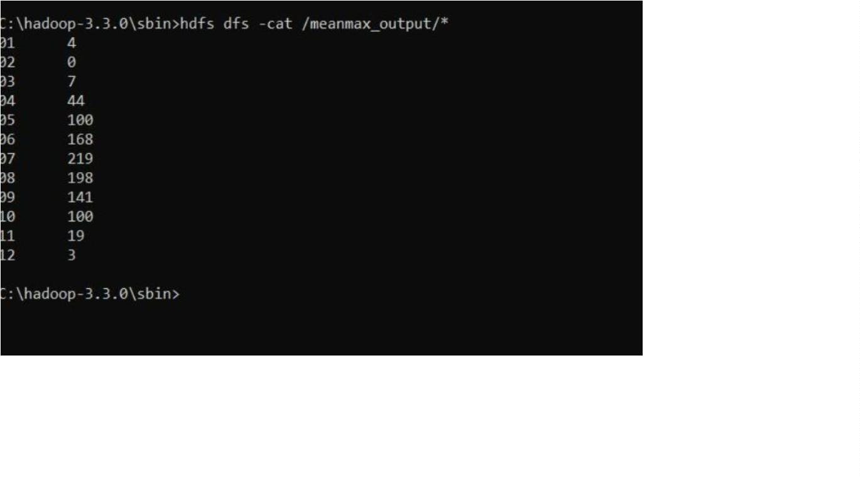

LAB 7
For a given Text file, Create a Map Reduce program to sort the content in an
alphabetic order listing only top 10 maximum occurrences of words
TopNDriver.class
import
java.io.IOException;
import
import
import
import
import
import
import
import
import
import
java.util.StringTokenizer;
org.apache.hadoop.conf.Configuration;
org.apache.hadoop.fs.Path;
org.apache.hadoop.io.IntWritable;
org.apache.hadoop.io.Text;
org.apache.hadoop.mapreduce.Job;
org.apache.hadoop.mapreduce.Mapper;
org.apache.hadoop.mapreduce.Reducer;
org.apache.hadoop.mapreduce.lib.input.FileInputFormat;
org.apache.hadoop.mapreduce.lib.output.FileOutputFormat; import
org.apache.hadoop.util.GenericOptionsParser; public class TopN {
public static void main(String[] args) throws Exception {
Configuration conf = new Configuration();
String[] otherArgs = (new GenericOptionsParser(conf, args)).getRemainingArgs(); if
(otherArgs.length != 2) {
System.err.println("Usage: TopN <in> <out>");
System.exit(2);
}
Job job = Job.getInstance(conf);
job.setJobName("Top N");
job.setJarByClass(TopN.class);
job.setMapperClass(TopNMapper.class);
job.setReducerClass(TopNReducer.class);
job.setOutputKeyClass(Text.class);
job.setOutputValueClass(IntWritable.class);
FileInputFormat.addInputPath(job, new Path(otherArgs[0]));
FileOutputFormat.setOutputPath(job, new Path(otherArgs[1]));
System.exit(job.waitForCompletion(true) ? 0 : 1); }
}
TopNCombiner.class
samples.topn;
java.io.IOException;
package
import
import
org.apache.hadoop.io.IntWritable;
import
org.apache.hadoop.io.Text;
import
org.apache.hadoop.mapreduce.Reducer;
21

public class TopNCombiner extends
Reducer<Text, IntWritable, Text,
IntWritable> { public void reduce(Text
key, Iterable<IntWritable> values,
Context context) throws IOException,
InterruptedException {
int sum = 0; for (IntWritable
val
val.get();
context.write(key, new IntWritable(sum)); }
:
values) sum +=
}
TopNReducer.class
package
import
samples.topn;
java.util.Map;
import
import org.apache.hadoop.mapreduce.Reducer;
import
import java.util.LinkedHashMap;
org.apache.hadoop.io.IntWritable;
java.io.IOException;
import
import
import
class
java.util.HashMap;
java.util.stream.Collectors;
org.apache.hadoop.io.Text;
public
TopNReducer extends Reducer<Text, IntWritable, Text, IntWritable> { private Map<Text,
Integer> countMap = new HashMap<>(); public void reduce(Text key, Iterable<IntWritable>
values, Context context) throws
IOException, InterruptedException {
int sum = 0; for (IntWritable val
:
values) { sum += val.get();
}
countMap.put(new Text(key), sum);
}
protected void cleanup(Context context) throws IOException, InterruptedException {
Map<Text, Integer> sortedMap = countMap.entrySet().stream().sorted(Map.Entry.<Text,
Integer>comparingByValue().reversed()).limit(20).collect(Collectors.toMap(
Map.Entry::getKey,
Map.Entry::getValue,
(e1, e2) -> e1,
LinkedHashMap::new)); for (Map.Entry<Text, Integer> entry
:
sortedMap.entrySet()) { context.write(entry.getKey(), new
IntWritable(entry.getValue()));
}
}
}
TopNMapper.class package samples.topn; import java.io.IOException;
import java.util.StringTokenizer; import org.apache.hadoop.io.IntWritable;
import
org.apache.hadoop.io.Text;
import
org.apache.hadoop.mapreduce.Mapper; public class TopNMapper extends
Mapper<Object, Text, Text, IntWritable> { private static final IntWritable one
22

=
new IntWritable(1); private Text word = new Text(); private String tokens =
"[_|$#<>\\^=\\[\\]\\*/\\\\,;,.\\-:()?!\"']";
public void map(Object key, Text value, Mapper<Object, Text, Text, IntWritable>.Context
context) throws IOException, InterruptedException
{
String cleanLine = value.toString().toLowerCase().replaceAll(this.tokens, " ");
StringTokenizer
itr
=
new
StringTokenizer(cleanLine);
while
(itr.hasMoreTokens())
{
this.word.set(itr.nextToken().trim());
context.write(this.word, one);
}
}
}
OUTPUT
23
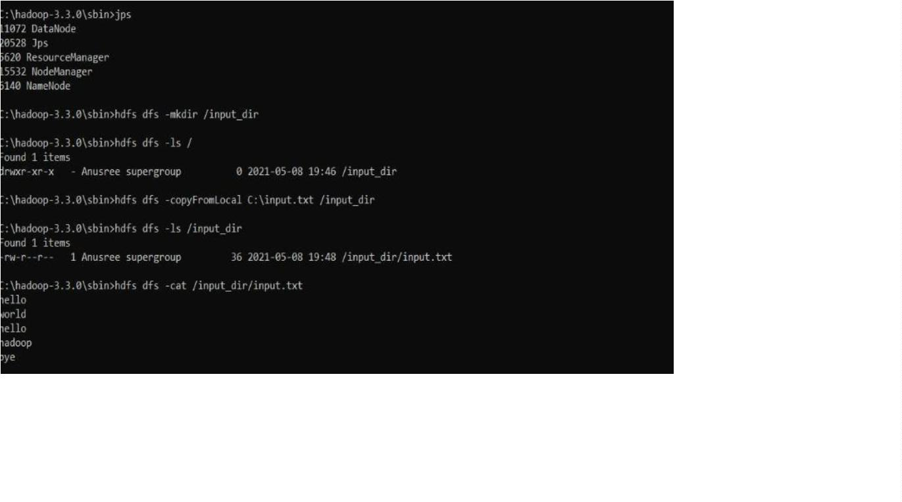

24
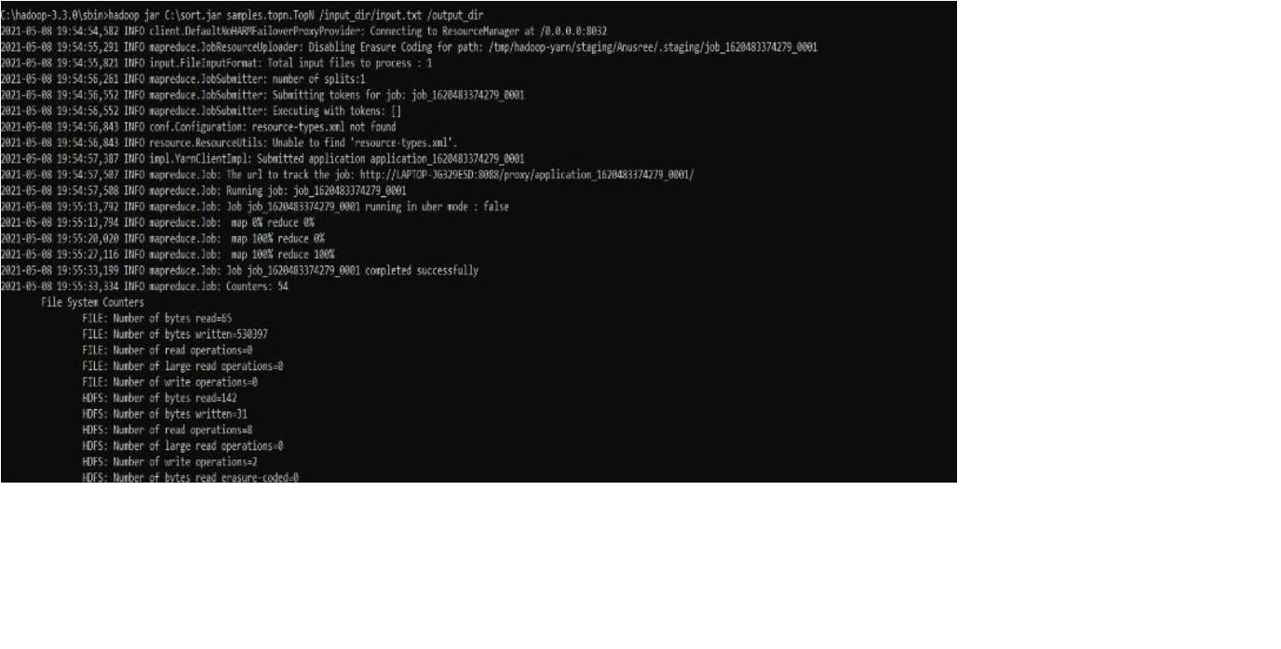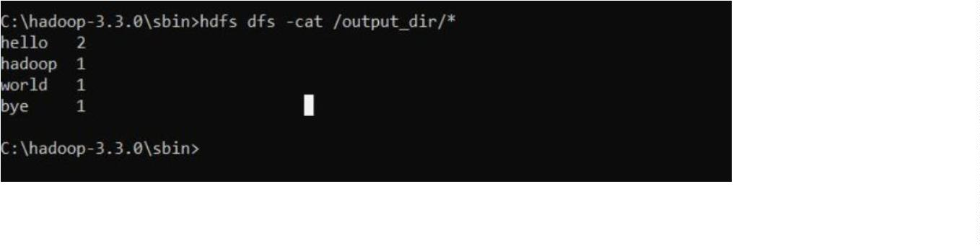

LAB 8&9
1
. Write a Scala program to print numbers from 1 to 100 using for loop.
object ExampleForLoop1 { def
main(args: Array[String])
{
for(counter <- 1 to 100) {
print(counter + " ")
}
println()
}
}
OUTPUT
2
. Using RDD and FlatMap count how many times each word appears in a file
and write out a list of words whose count is strictly greater than 4 using
Spark.
from pyspark import SparkContext sc =
SparkContext("local", "SimpleWordCount")
#
Read file rdd = sc.textFile("file.txt") # Replace with
your filename
#
Count words counts = (rdd.flatMap(lambda
line: line.split())
.
.
.
map(lambda word: (word, 1))
reduceByKey(lambda a, b: a + b)
filter(lambda x: x[1] > 4))
#
Show result for word, count in
counts.collect():
print(word, count)
sc.stop()
OUTPUT
25
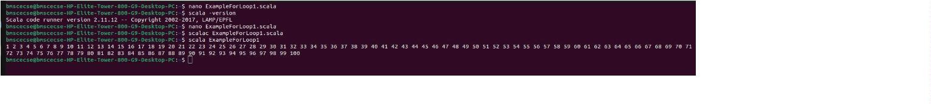

26
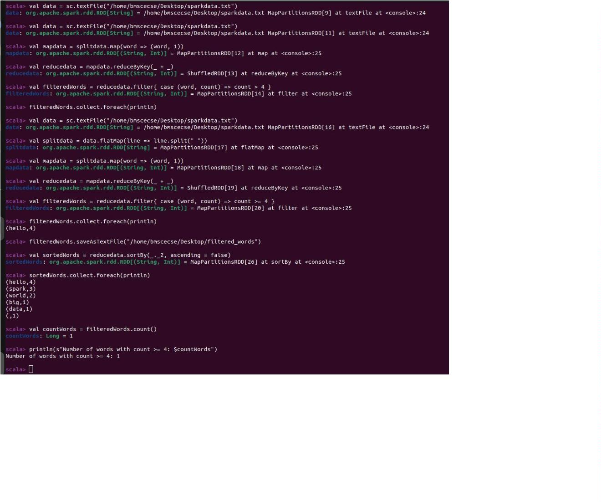

LAB 10
Write a simple streaming program in Spark to receive text data streams on a
particular port, perform basic text cleaning (like white space removal, stop
words removal, lemmatization, etc.), and print the cleaned text on the screen.
(Open Ended Question).
import
org.apache.spark.SparkConf
import
org.apache.spark.streaming.{Seconds,
StreamingContext}
import org.apache.spark.streaming.StreamingContext._
object SimpleStreamingCleaner {
def main(args: Array[String]): Unit = {
/
/
Create
Spark
configuration
and
StreamingContext
val
conf
=
new
SparkConf().setMaster("local[2]").setAppName("StreamingTextCleaner") val ssc = new
StreamingContext(conf, Seconds(5))
/
/ Connect to socket stream (e.g., using: `nc -lk 9999`) val
lines = ssc.socketTextStream("localhost", 9999)
/
"
/ Define stop words val stopWords = Set("a", "an", "the", "is", "in", "on", "and", "of",
to", "this", "that")
/
/ Define basic lemmatization map (for demo only) val lemmaMap = Map("running" ->
"run", "tests" -> "test", "files" -> "file", "words" -> "word")
/
/
Clean
lines.map(_.toLowerCase.trim) // lower case and trim
flatMap(_.split("\\s+")) // split into words
the
text
stream
val
cleaned
=
.
.
filter(word => !stopWords.contains(word)) // remove stop words
.
map(word => lemmaMap.getOrElse(word, word)) // basic lemmatization
/
/
/ Print the cleaned text cleaned.print()
/ Start the stream ssc.start()
ssc.awaitTermination()
}
}
27

OUTPUT
28
